A An Truong Primary school. | THE FIRST TERM TEST
Name:…………………………………… | School year: 2025-2026- Grade: 3
Class:…………......................................... | Time allowed: 60 Minutes.
Skills | Listening | Reading | Writing | Speaking | Total
Marks
Comments: |  |  |  | Supervisor singnature

LISTENING
TASK 1: Listen and circle.  (1mark)
- What’s this?
- It’s a hand b. It’s an eye.
- What’s this?
- It’s a nose. b. It’s an ear.
- What’s your hobby?
- I like walking. b. I like cooking.
4. What’s your hobby?
- I like painting. b. I like dancing.
TASK 2: Listen and number.   (1mark)
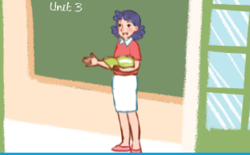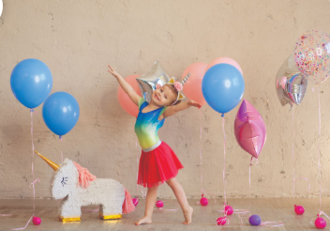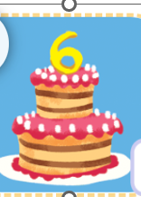
TASK 3: Listen and tick or cross (1mark)

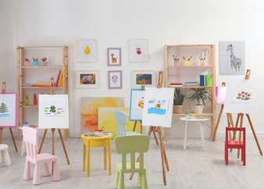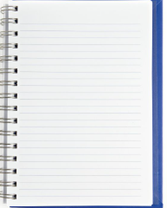
TASK 4: Listen and tick True or False. (1mark)

 | True | False
1. A: What's your name?
B: My name's Mary.
2. A: Is this Ms Hoa? B: Yes, it is.
3. A: Is that Mr Long? - B: Yes, it is.
4. Open your eyes!

SPEAKING
Task 1: Get to know each other.
- Hello. What’s your name?
- How are you?
- How old are you?
- What’s your hobby?
- What do you do at break time?
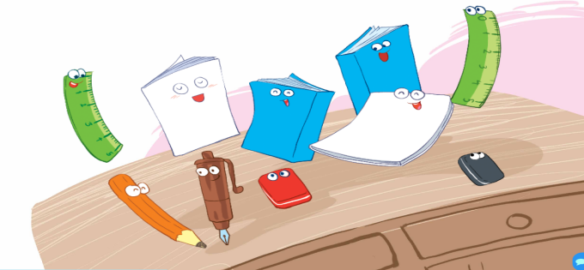
Task 2: Look and say

A An Truong Primary school. | THE FIRST TERM TEST
Name:…………………………………… | School year: 2025-2026- Grade: 3
Class:…………......................................... | Time allowed: 60 Minutes.

READING
TASK 1 : Read and complete. (1mark)

eight

hobby

Mary

name
Mr Long: Hi. What’ your(1)………………..?
Mary: My name’s (2)……………………………
Mr Long: How old are you?
Mary: I’m (3)………………….years old.
Mr Long: What’s your (4)…………………?
Mary: It’s swimming.

TASK 2: Read and circle .  (1mark)
- I have a book. | 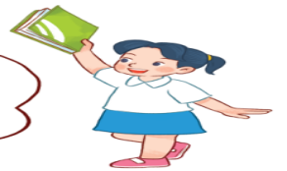  A. | 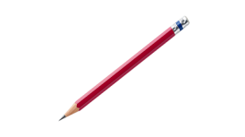  B.
- Open your book, please! | 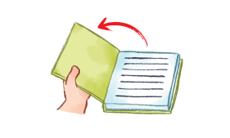  A. | 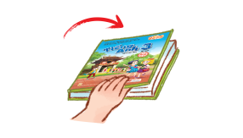  B
3. Let’s go to the classroom! |   A. |   B.
4.I play football at break time. | 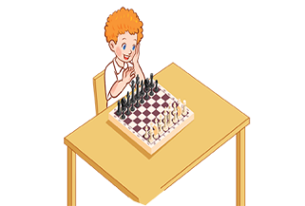  A. |   B.

WRITING
TASK 1: Look and write. (1mark)

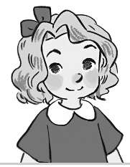  1. a-y-r-M M………… | 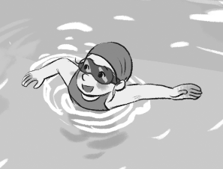  2. m i n g w i m s s…………………
  3. g i t h e e………………. | 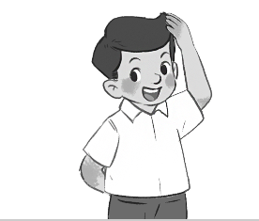  c h o u t t…………………

TASK 2: Put the words in order to make correct sentences. (1mark)

- Bill . / Hello, / Nam . I’m

- that / Is / my / classroom?

- old / How / are / you?

- These / my / are / notebooks.

